

1. **Individual Contribution for Documentation, Presentation, Audit**

|  |  |  |  |
| --- | --- | --- | --- |
| **Student Name** | **Documentation** | **Presentation** | **Audit** |
| Ajinkya Gagare | ...........Plz fill ur work......... | Login, Register for alpha release, ICT infrastructure | Project development and create environment for new user |
| Harshavardhan Shirole | ..............plz fill ur work | Shopping cart for alpha release, Plan for beta and final release | Alpha release for shopping cart, Configuration management tools |
| Jagdeep Kaur Tiwana | Configuration management, Prototypes Design | Project Introduction, Description and present basic php shopping cart | First Alpha Release, Client meeting for final alpha release and plan for beta and final release, prototype designs |
| Manpreet Kaur | User stories | Homepage design, alpha release introduction, make ppt for presentation | Velocity Chart, alpha beta log form, Burn down chart |

1. **Alpha Release:**

Introduction: Our website is ecommerce website about online shopping for ladies wear and Accessories. For the Alpha-release-iteration 1, we had a client meeting and then client told us his priorities for this website. Firstly, He wants the attractive responsive homepage and Login & Signup form for the customer registration and other option for the customer to explore the website as a guest without any registration. Second main priority is shopping cart. He wants shopping cart for the customers to place a order.

* 1. **Homepage:** Homepage is very attractive and make by using bootstrap. On the homepage we mention all the categories of clothes and Accessories.

**Navigation bar and Header:**



We provide the client contact information in header bar. When user will hover the mouse on, then it will show the client’s contact information. Next is, search panel to find the items. On the right side of search panel, there is Login and Register options for the user. Navigation bar is all about different kinds of products. Some of these links have dropdown menu.

Below the navigation bar, there is a slider, which shows the different types of dresses.

**View of Slider 1:**

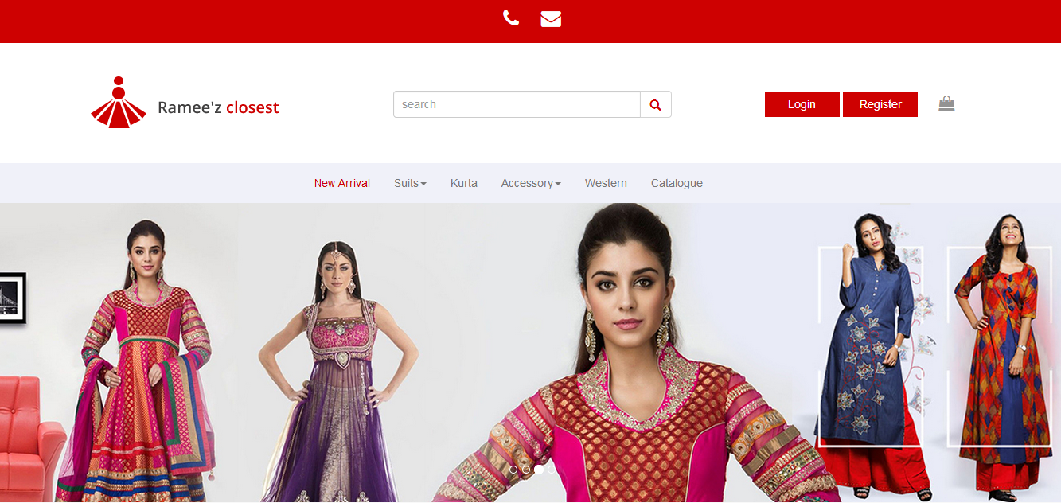

**View of Slider 2:**

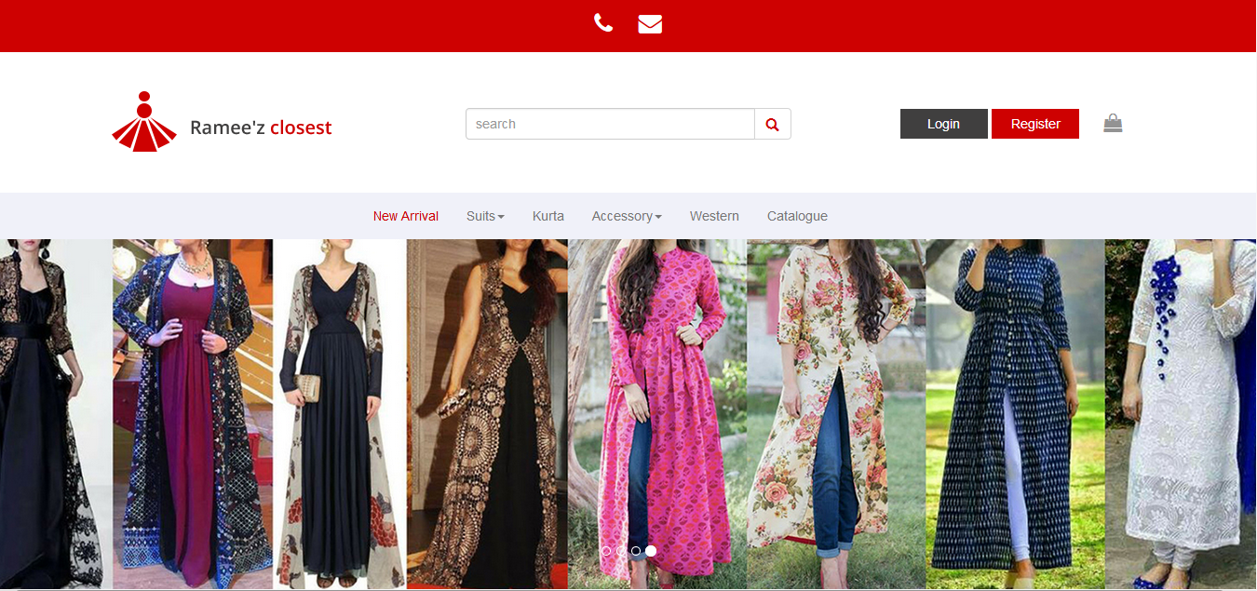

**View of Slider 3:**

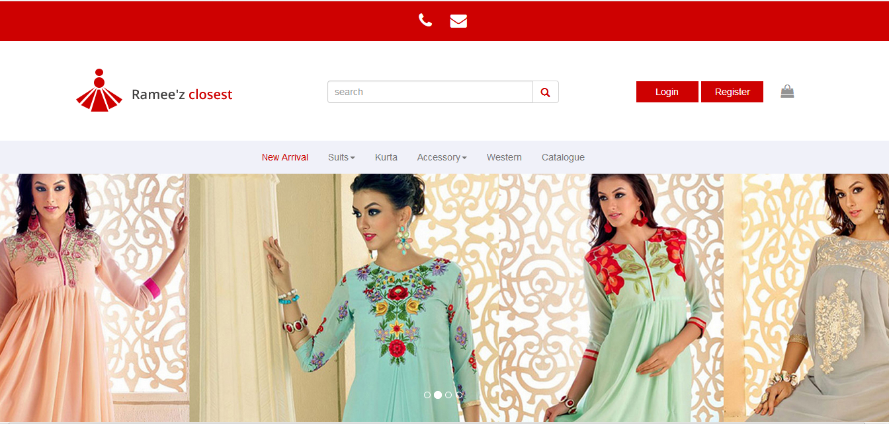

Below the slider, we put four different categories of dresses with images. Each image has the flip feature. When user hover the mouse over picture, then it flips. Here are screenshot for this:

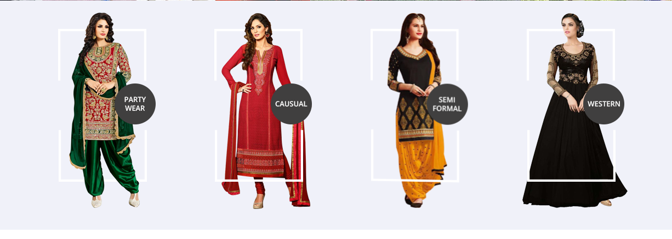

So, when user click on image then image flip and other image is shown up.

Under this bar, we put some brief information about the website. This information is not provided by client yet, so with the client permission, we provide this information by our own. Client said that he will provide it later. Client wants a container with all categories of clothes, which are currently in fashion. So, this container (In trend) is with the zoom feature over every image .

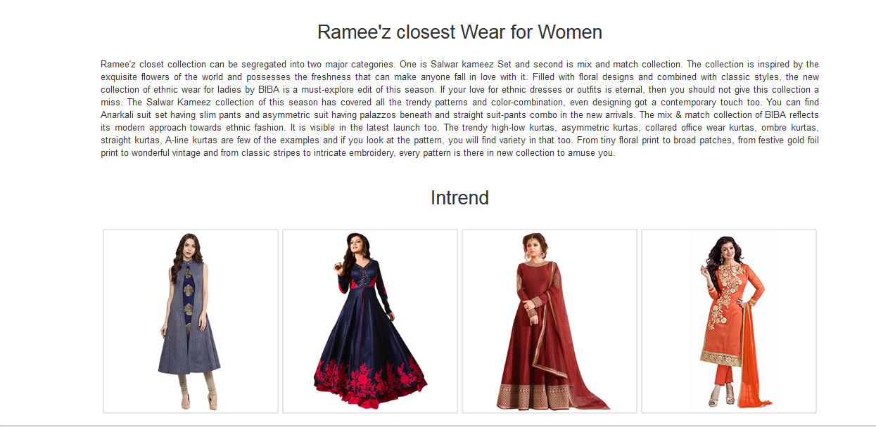

Last container is for jewellery, bags and other accessories with static images. Also we give some links for popular different kind of dresses and social media links of client profile. This links are currently not working, because we will develop these features in Beta-release-iteration 2. Here is screenshot of bottom part of homepage with the quick links and footer.

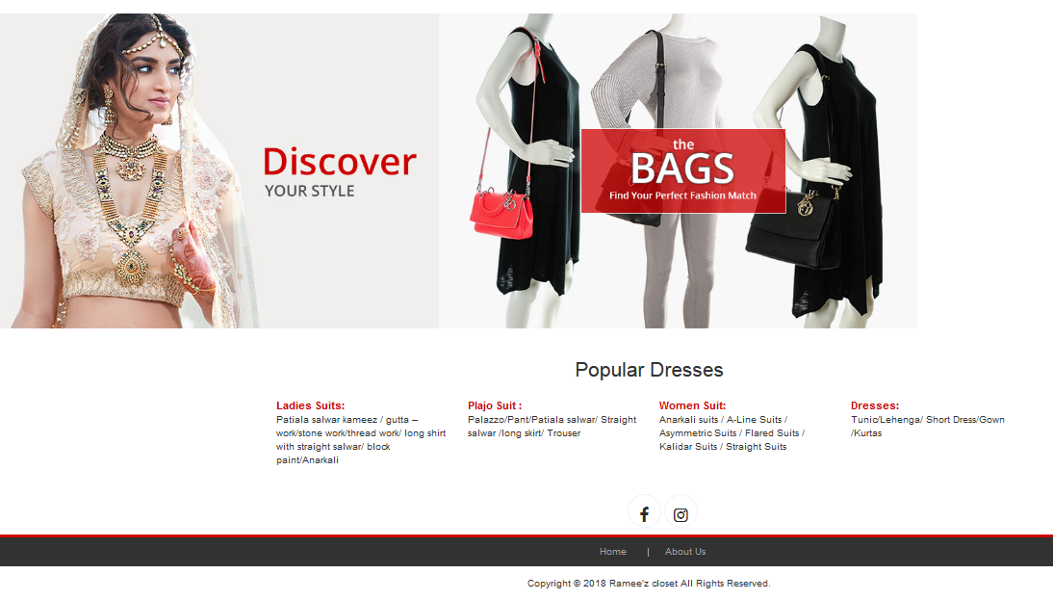

* 1. **Login and Signup Form:** So firstly, we worked on Login and Signup form. We use the Mongo DB for this purpose. If customer wants to make an order for any material, then firstly he must have to Login if he is already a member of website. In case, he is new to website, he must use the Registration form. Here are some screenshots of Login and Signup form.

This is registration form for the new user. User have to fill the form, all the details goes to database and saved. After clicking the submit button, user is registered.

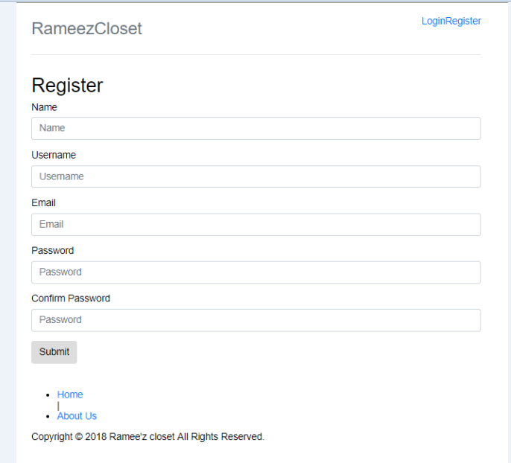

After the user registration is completed, following screen display to the user. Now he can login for his account.

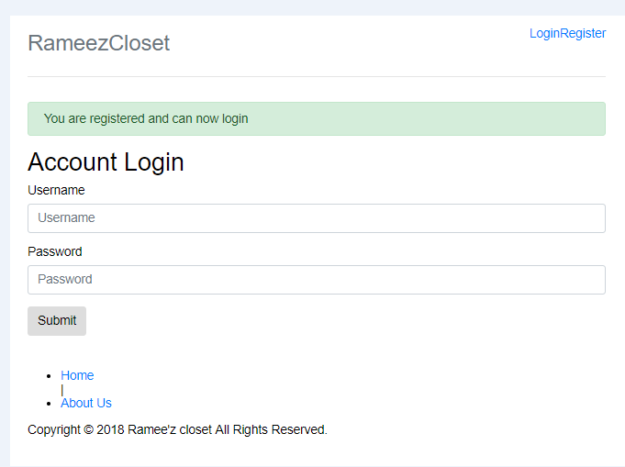

This Account login screen is for already registered members.

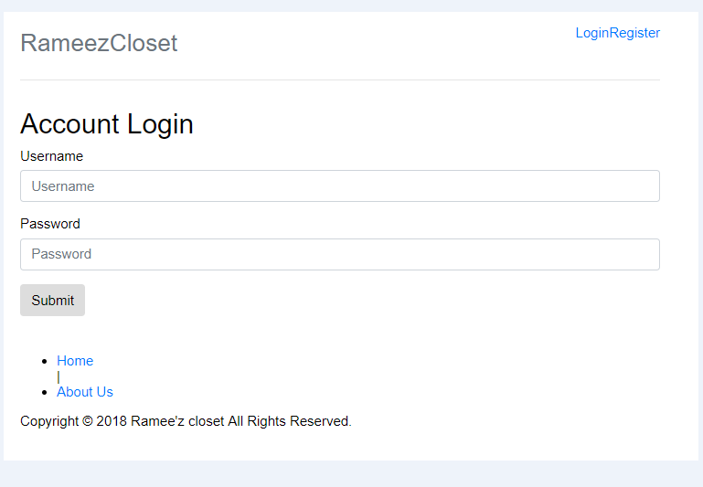

This picture is about Mongo DB. All the entries filled in registration form, goes and save here. Here is example of new entry for registration and its all details are saved in database.

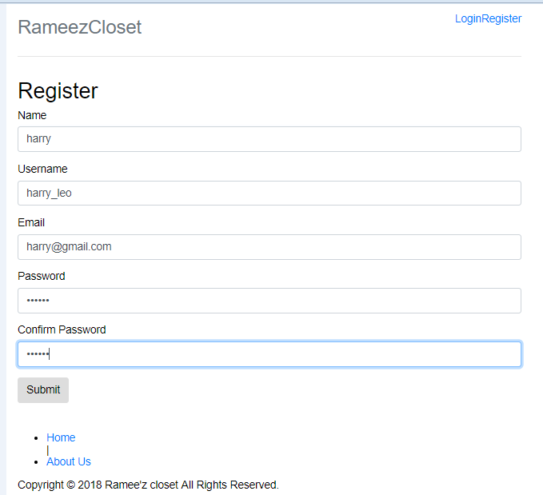

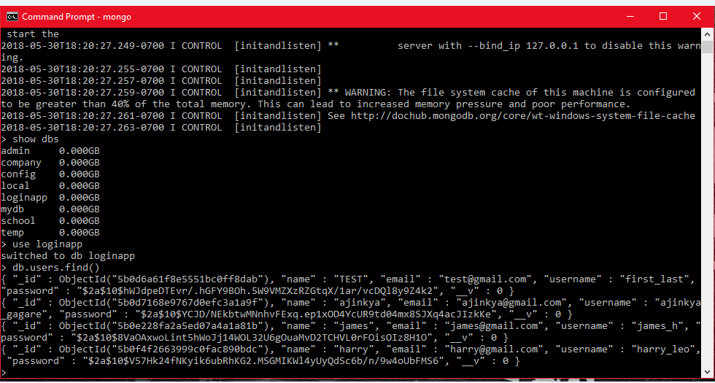

After the Login, following screen display to customer.

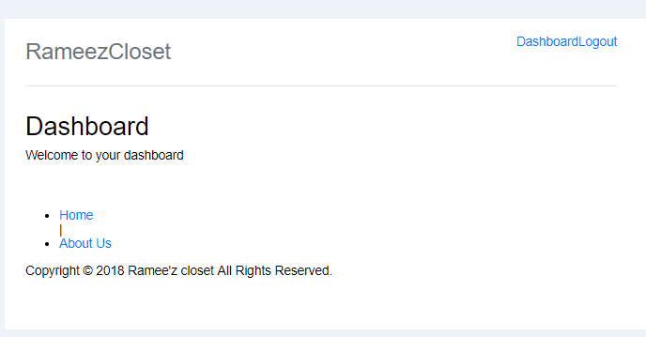

Validation screen for email and password.

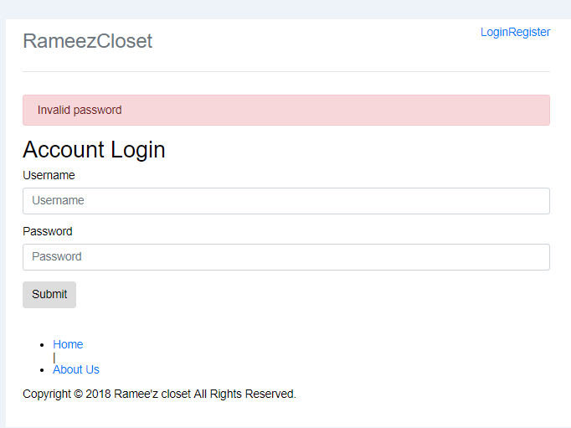

* 1. Shopping Cart .................................................................................................

................................................ ........................

..............................................................................

**2.1 Alpha Beta Log form:**

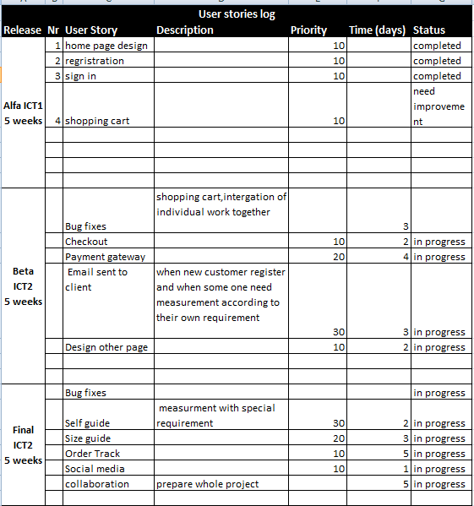

1. **Client meeting for alpha and beta approval:**

Before the alpha release, we met the client in James Cook university at 7.30pm on Monday, 14th may. We showed him the homepage. He said that it you did work very well, beyond his expectations. However, he wanted some improvements in homepage. He said that he also want to add some accessories information and a container which is all about the latest fashion of different kinds of clothes. Then we showed him the Registration form as dynamic page and design. But it was not connected with database. He liked it but said that he wants login and Register as his first priority and stated that it should be connected with database. Later we talked about the shopping cart. He showed us some design from random websites for the shopping cart that he wants for his website. Then we showed him our basic shopping cart design, he seems happy with that. He told us to go ahead with that design.

After the client meeting, we started work for final alpha release and changes that he wants from us. As, our client is out of country from couple of weeks. So, we cannot meet him personally. But he provided us his social media contact information. So, we are continuing in touch with him via social media. He was pretty satisfied with homepage design. However, he wants some improvements in Login and Signup form. He wants some text notification on phone or email, whenever new user registers.

For the Beta release, we talk with our client and told him about our next plan for the website. We told him that next, we will work on Checkout and payment gateway. We also told him about the size chart for the customer. Client stated that he wants a custom size chart for the customer, in which customer can give description of dress size and he wants notification on phone about the measurements of customer along with customer name and dress material. In beta release we will also make some improvements in our shopping cart for e.g. increase the quantity of item, delete item from cart and final total cost of shopping.

For the final release we proposed order track feature for the customers, which is really liked by our client. Website will have all the features find the product from search panel, add and remove item from cart, size chart for dress selection, checkout, payment and order track facilities. Lastly, Website will have the social media links for the customers.

**3.1 Velocity Chart:**

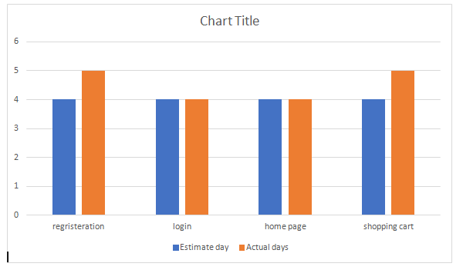

**3.2 Burn Down Chart:**

1. **Project Release and Development Infrastructure**

4.1 **Configuration Management Tools:** For this project, Git would be the version control system for managing the different versions of it.

We have picked Git because as (git-scm, 2018) says, it is easy to learn and because is one of the most popular distributed version control system.

GitHub would be used for the repository to help to getting the code in one place as (GitHub, 2018) stated. By doing so, it would be easier to manage the change of all the developer team in one place and it would be easy to add new Developers.

We create a repository naming ICT-1 and all team members are invited to collaborate in this repository.

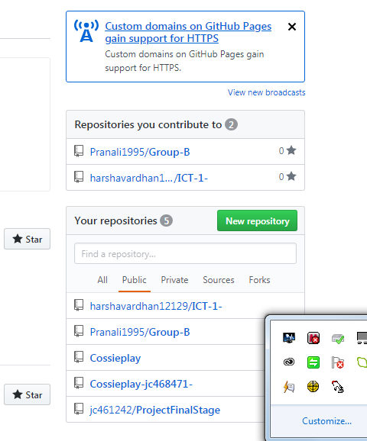

*Figure 1: ICT-1 repository*

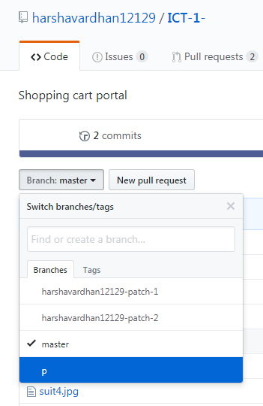

*Figure 2: Patch1 and Patch 2 branches for Alpha AND Beta development*

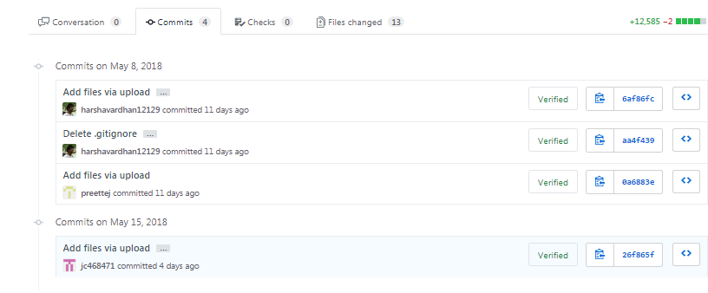

*Figure 3: Commits for the project development before alpha release*

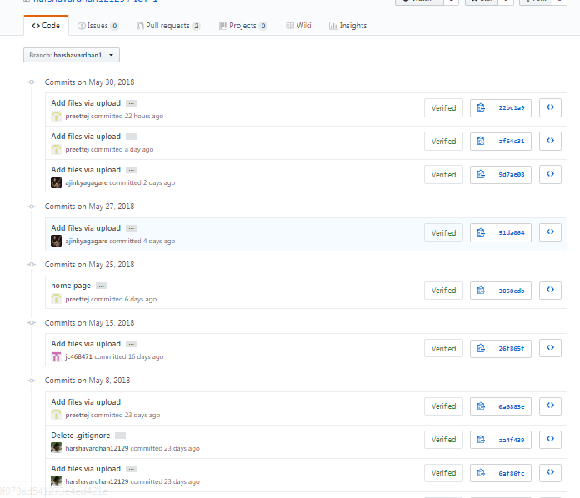

*Figure 4: Commits for the project development after alpha release*

Another software that we used for communications purpose with team members is Trello. We make personal account on Trello and then make a team ICT 1 for the project and send invitation to all team members via their email to join the team.

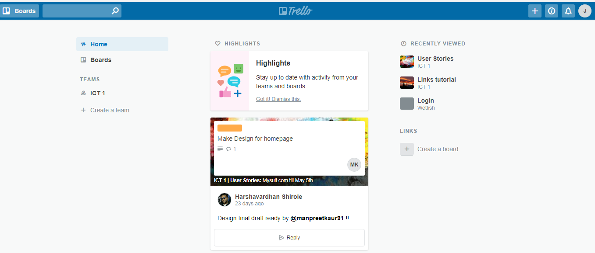

*Figure 5: Homepage with ICT 1 Team*

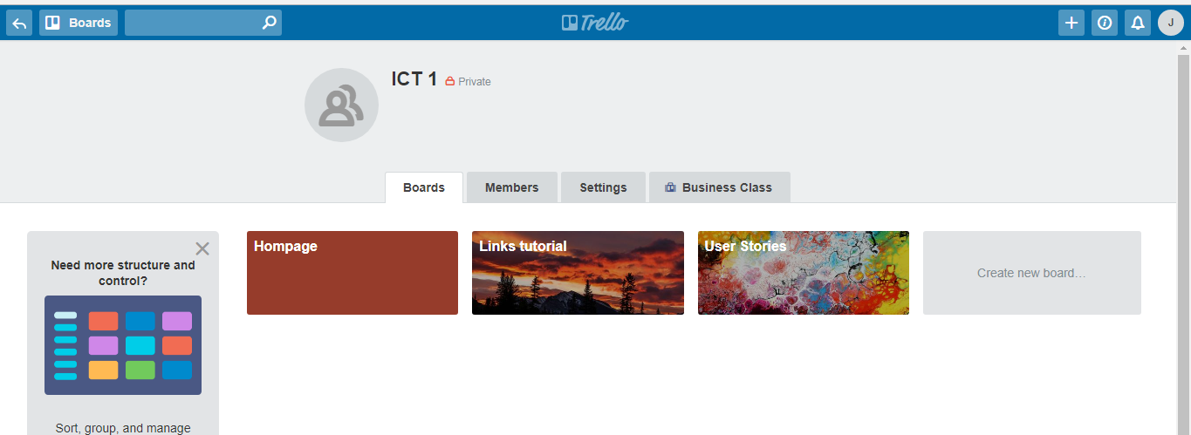

*Figure 6: ICT 1 team page*

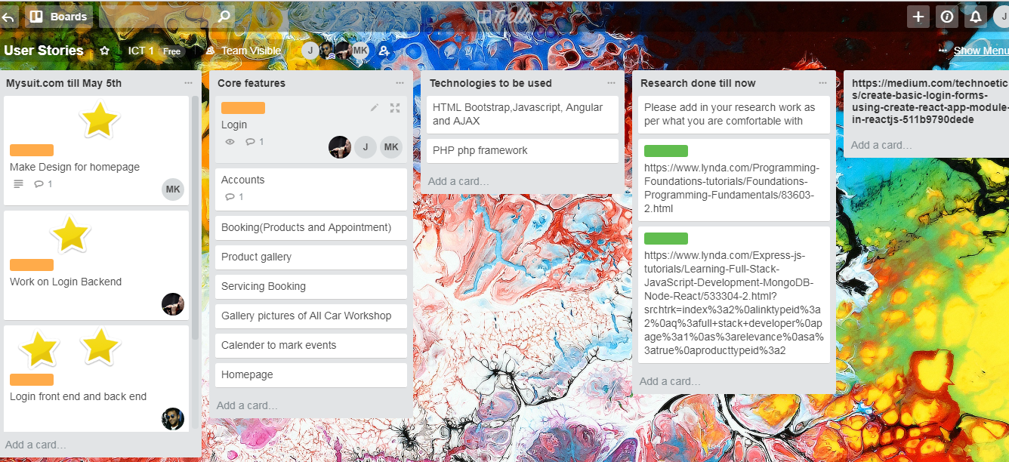

*Figure 7: Planning and reaserch for the project*

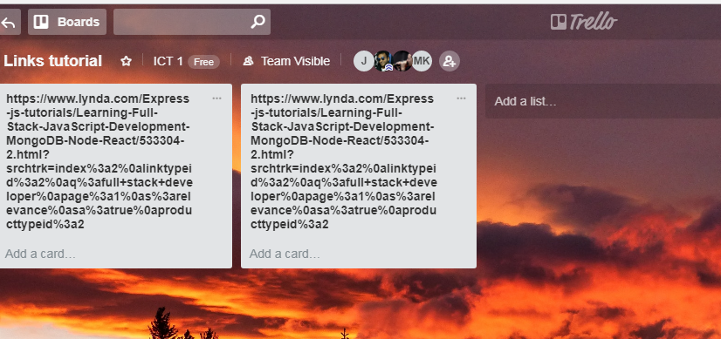

*Figure 8: Shared links of some tutorials needed for development*

**4.1.1Setup environment for new developer:** If any new developer will want to join us then we create a friendly environment for that person to join us and go through all the development. He will be added as a new collaborate in ICT 1 repository on Github and also that person will be added in our Trello team ICT 1.

**4.1.2 Project Tools &** Programming Languages : HTML/CSS3 Bootstrap framework, SQL Lite , MongoDB , Cakephp, React and Node.js

* Installation of Node.js

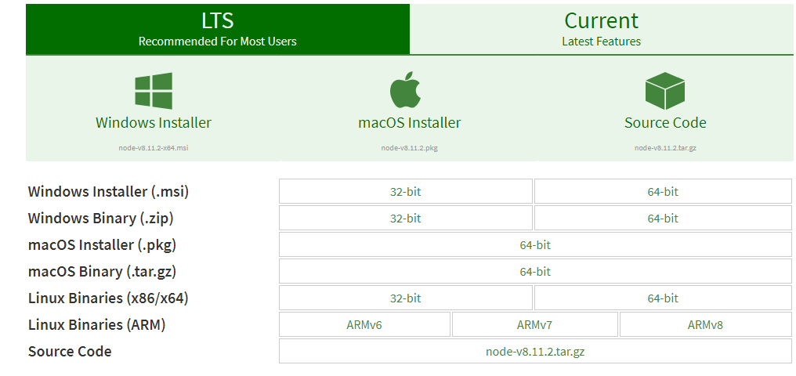

After installing the node.js, we need to run following code in command prompt to install react app in computer.



Then the welcome page of react will appear on local host for frontend.

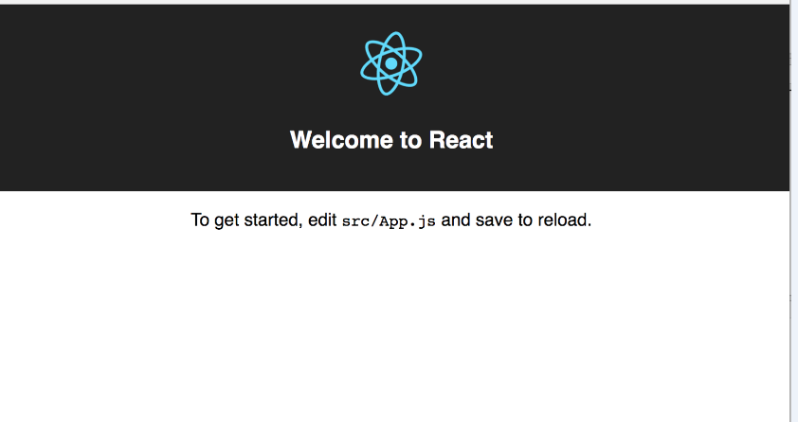

*Figure 9: Welcome react app page*

* **Installation for Mongo DB:**

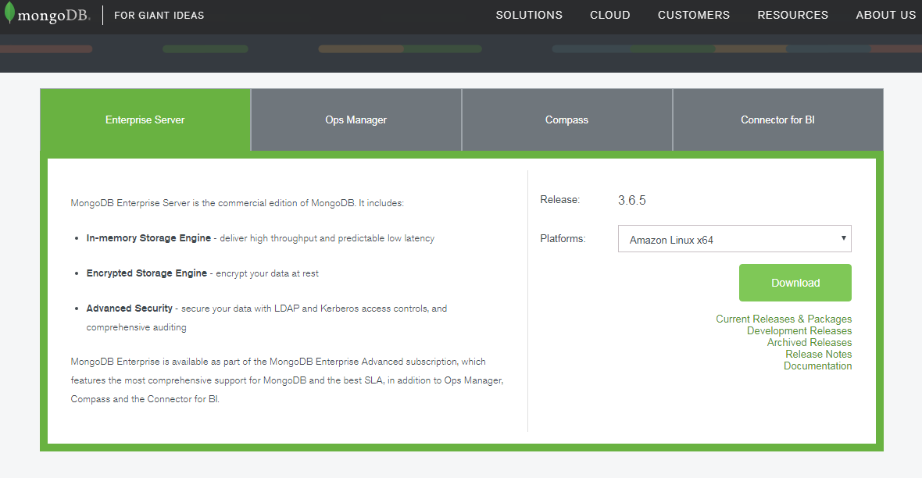

* Connecting to local host through Gitbash:

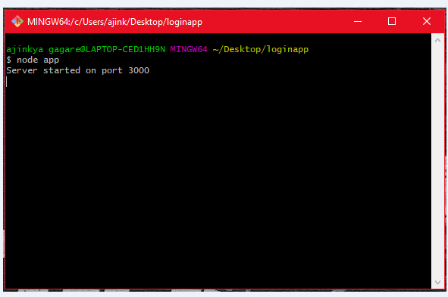

* IDE : Atom, Dreamviewer, Brackets and Microsoft Visual Code.

We used the Atom as editor for the coding purpose, because it is most attractive tool with some in build packages and classes. We download the Atom from the http:// atom.io website.

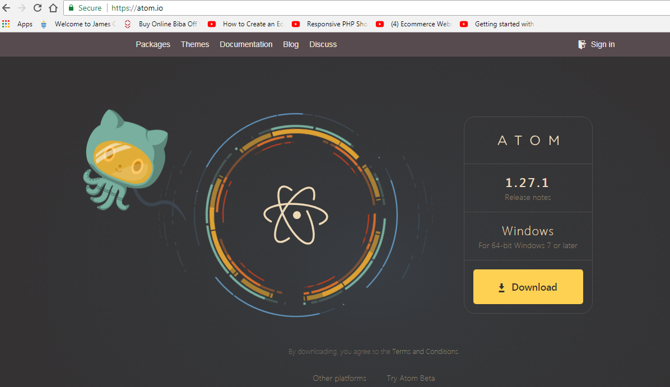

Some team members used the Microsoft Visual Code and Brackets.

* Code for login app in MVC:

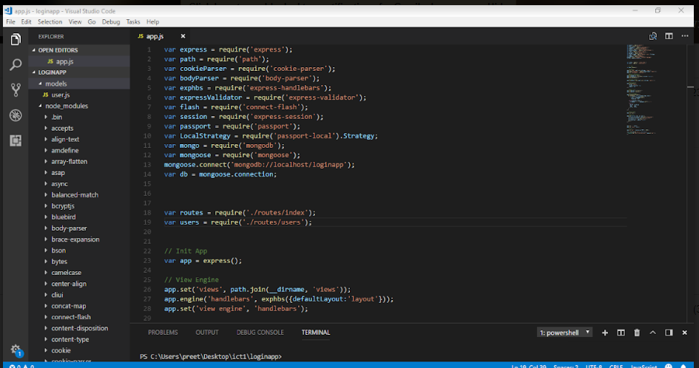

* Code for homepage using Brackets:

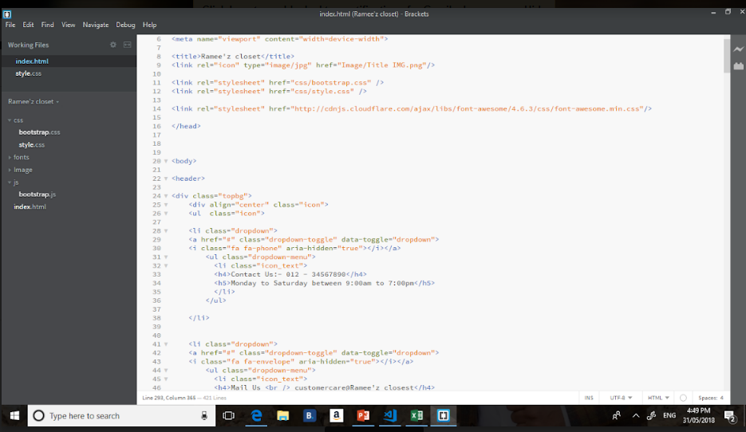

* + 1. **Testing Tools:** Junit, Local server testing and then released on a temporary server till the website goes live. Planning to test all backend and dynamic operations when they are lively tested checking full functionality per tests by user stories and acknowledging each one.

**4.2: Prototypes for Beta Release:**

* Check Out and make order Page:

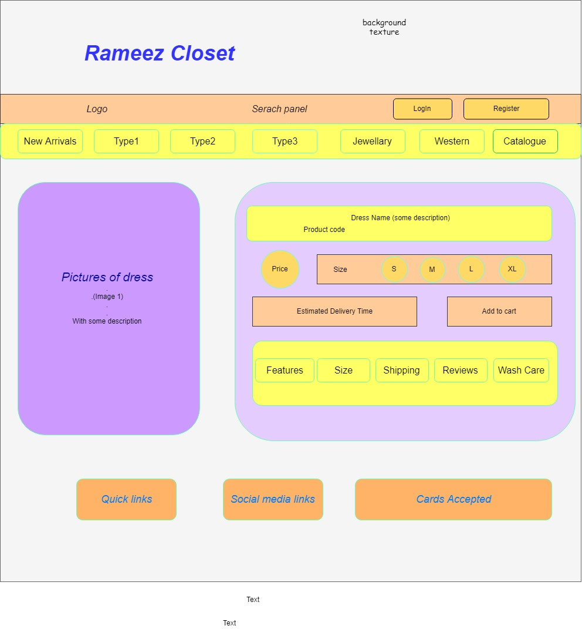

* Payment Summary Page:

